THESIS

Table of Contents

Title: 3

Acknowledgements 3

Abstract 3

Declaration 3

Introduction 4

1. Fungi 4

2. Human-Fungal Interactions 5

3. Candida and Candidiasis 6

3.1 History 6

3.2 Morphological switching and mating in *Candida albicans* 8

3.3 General features of *Candida glabrata* 10

3.4 Sources of *C. albicans* and *C. glabrata* infections 12

4. Basics of virulence by *Candida* *spp*. 14

4.1 Adherence 14

4.2 Morphological switch 16

4.3 Pigmentation 16

4.4 Signaling cascades 17

4.5 Response to Stress 17

5. Host immune response against *C. albicans* and *C. glabrata* infections 17

5.1 Macrophages 18

5.2 Neutrophils 20

5.3 Antimicrobial peptides 21

5.4 Dendritic cells 22

5.5 T-cells 23

5.6 B-cells 24

6. Antifungal Drugs 24

6.1 Polyenes 24

6.2 Allylamines 26

6.3 Morpholines 26

6.4 Azoles 27

6.5 Flucytosine 29

**6.6** Echinocandins 30

Candida glabrata 32

Chapter 1: Integration of genomics data to infer stability in C glabrata 33

Chapter 2: Multiple stress responses by C glabrata 33

Chapter 3: Heat stress response in pathogenic fungi 33

Title:

Acknowledgements

Abstract

Declaration

Introduction

1. **Fungi**

Fungi exists as a large group of ubiquitous eukaryotic organism which display wide variety in their ecological niche, size, morphology and lifestyle. Evolutionarily they are more complex than prokaryotic cells and hence lie at the border line of prokaryotes and highly developed eukaryotes. Considering their diversity and structural complexity, fungi belong to independent kingdom in addition to plants and animals in tree of life. They have emerged with unique functions like, pathogens for plants or animals, as decomposer, in industry to produce many metabolites. Owing to diversity in their behavior, fungi have been denoted as “model organism” to study genetics, cell biology (Ryan and Sherris, 2014).

In nature, about 99,000 different fungal species have been identified which exist as yeast, molds, mushrooms, smuts, rusts etc. They are placed at the lower most class of energy cycle i.e. decomposers as they absorb nutrients from dead, decaying substances(Gadd, 2007). They have also been found to live in symbiotic association with plant, animals and other fungi. Their ability to break down tough materials viz. cellulose and woods by specialized enzymes which have now gained importance in commercial sector like pharma, food and chemical industries. Along with their beneficiary roles they have evolved as pathogenic organisms devastating hectares of land in an agriculture season. They not only produce industrially important enzymes but also toxic carcinogenic enzymes like aflatoxin, mycotoxin through eatables to humans and animals. In last two decades, about 200 fungal species have been reported to cause diseases in humans, killing about 1.6 million individuals and over one billion people are diagnosed by dreadful fungal diseases annually (Almeida et al., 2019; Kauffman et al., 2011). Some of the commensal fungi turn pathogenic in immunocompromised individuals suffering from severe diseases like AIDS, cancer or organ transplants. Despite of the availability of the advanced medical technologies, diagnosis the treatment of fungal infections remains a major challenge for clinicians.

1. **Human-Fungal Interactions**

Fungal species are ubiquitous in nature and interact with humans through various modes for instance, the air we inhale, the food we eat and those residing on our skin (Benedict et al., 2016). Fungi is one of the major components of our microbiota inhabiting in gut, respiratory track etc. (Figure 1). They have huge influence on host physiology ranging from their involvement in digestion to building host immune system as commensal organisms to true pathogens (Hall and Noverr, 2017; Underhill, 2014)*.* For instance, fungal species commonly belonging to *Candida, Fusarium, Aspergillus, Malassezia* genus were reported in the individuals with different diet habits (Hallen-Adams and Suhr, 2017). *Malassezia spp.* are predominantly observed in commensal association on human skin controlled by skin’s lipid composition(Findley et al., 2013). While more than 50 genera have been identified to inhabit in intestinal gut like *Candida albicans*, *Saccharomyces cerevisiae*, *Candida* *glabrata*, *Candida* *dubliniesis* and *Candida* *parasilosis*. *Candida* species have also been isolated from vaginal microflora along with *Aspergillus*, *Alternaria*, *Clodosporium* (Underhill, 2014). In vagina, these fungal species help to balance the microenvironment by inhibiting the colonization of bacteria (like E. coli) (Hall and Noverr, 2017). Owing to their diverse function in maintaining host microbiota they were traditionally being considered as non-pathogenic commensals and medically insignificant. However, in specific hosts or during immune-suppression these organisms undergo transition from commensals to pathogenic state confined to their niche or causing life threatening systemic infections (Hall and Noverr, 2017). Currently, fungal pathogens has emerged as one of the leading cause of mortality and morbidity at alarming rate (Gullo, 2009; Pfaller and Diekema, 2007; Pfaller et al., 2006; Richardson and Lass-Florl, 2008). Majority of fungal species causing infection in world belong to *Candida*, *Aspergillus* and *Cryptococcus* (Bajpai et al., 2019; Pfaller and Diekema, 2007)*.* Table1 lists common fungal pathogens, their sites of infection, incidences and mortality rate (<https://www.gaffi.org/why/fungal-disease-frequency/>).

**Table1: Pathogenic fungi and their epidemiology**

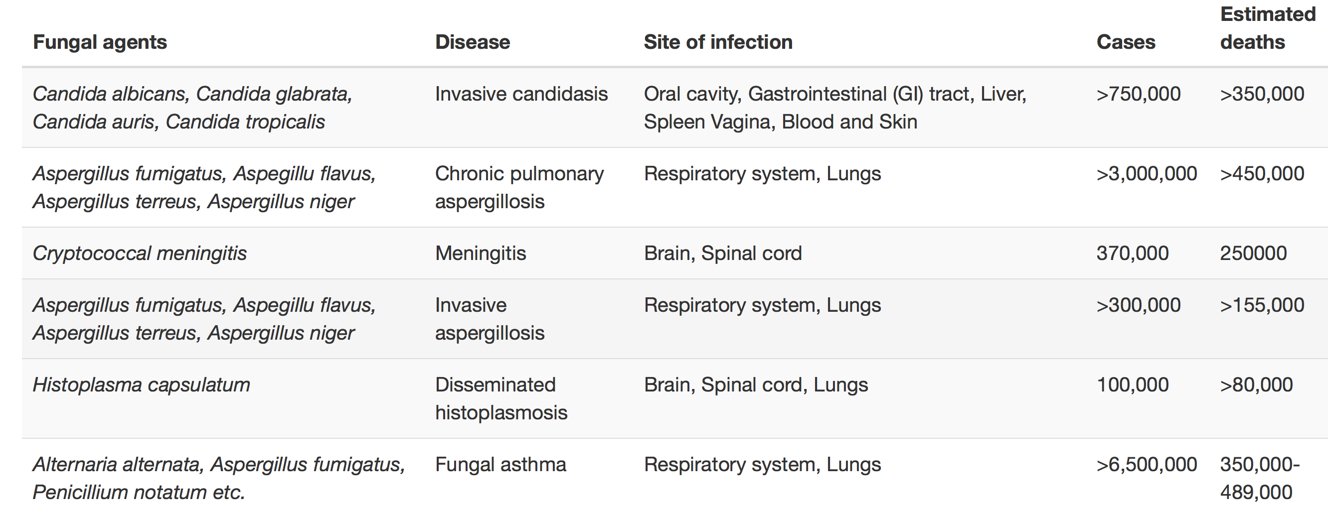

## **3. Candida and Candidiasis**

**3.1 History**

Existence of Candida species is known since 4th century BC, mentioned by Hippocrates as “mouths affected with aphthous ulcerations” (Lynch, 1994). Later, in 1665 Pepsy Diary first described this oral infection as “oral thrush” originating from the host. In 1786, funds were approved to perform research on oral thrush by Royal Society of Medicine in France, which was the first funded project to investigate oral Candiasis (Lynch, 1994).Langenbeck in 1839, first stated that this oral thrush is caused by fungus further described their morphological forms known today as hyphae, branched pseudo hyphae and blastoconidia (Knoke and Bernhardt, 2006). J. H Bennet in 1844, concluded that the diseases greatly affect host causing decrease in vital powers, two years later in 1846, Berg showed relationship between Candida and thrush (Lynch, 1994). Later, evidences of presence of dimorphic fungi were also presented at gastro-intestinal tract and vaginal mucosa but the global identification of this fungi was the next question.

In 1847, a French mycologist Charles Phillip Robin classified this organism as *odium* *albicans*, where “*albicans*” means to whiten (<http://www.whonamedit.com/doctor.cfm/23.html>). Later, Candida was misclassified into genus Monilia, a genus involved in rotting of fruits and leaves. Although clear morphological differences between oral thrush fungus and fungus in Monilia genus was elucidated for long time, clinicians still incorrectly referred Candida as Monilia (Barnett, 2008; Mccool, 2016). In 1923, Berkhout reclassified this fungus based on their differences and ability to infect humans, further naming it as Candida derived from Latin word *toga* candida meaning white robe worn candidates for roman senates (Lynch, 1994; Mccool, 2016). Detailed timeline of Candida discovery is depicted in Figure 1. This 200-yearlong debate on etiology and nomenclature of *Candida* *albicans* came to an end in 1954 at the Eight Botanical Congress, where it was officially recognized as *Candida albicans* (Barnett, 2004).

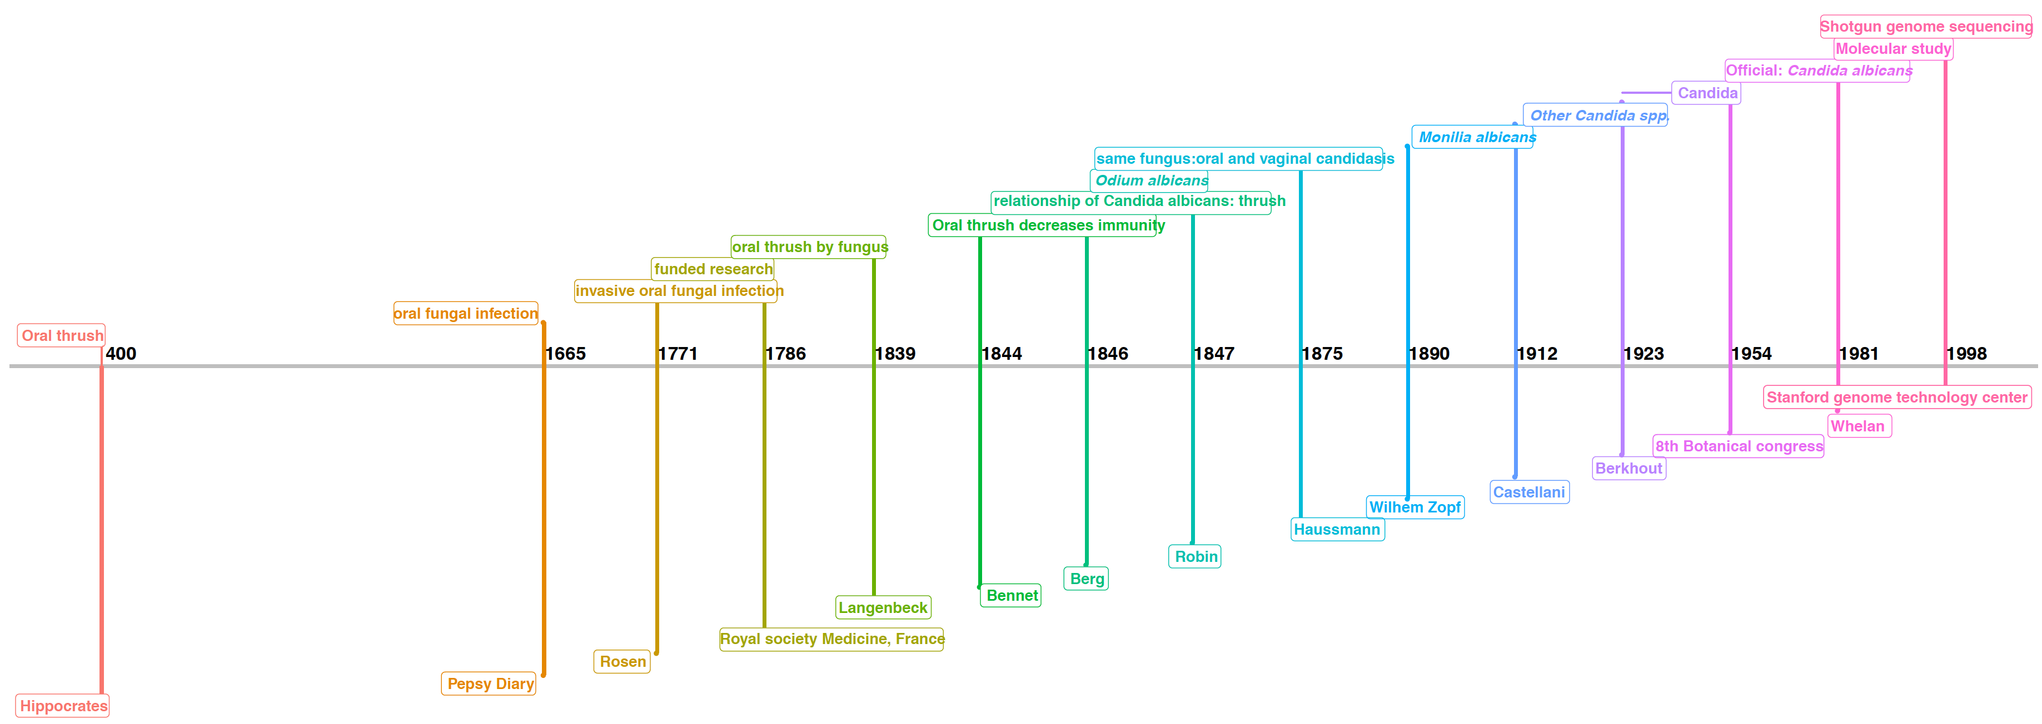

Figure 1: Timeline of Candida genus and origin of *Candida albicans*

More than 400 species of fungi are now classified under the genus Candida, these are yeast like organisms, anamorphic (sexual imperfect) showing polymorphism, by its ability to grow as budding yeast i.e. blastoconidia, mycelia and pseudomycelia. However, *Candida albicans, Candida glabrata Candida tropicalis, Candida Krusei* and *Candida parapsilosis* are the dominant species causing about 90% candida infections in humans(Lockhart et al., 2017). Moreover, they contribute to ~42% of all the fungal infections isolated from intensive care units. Among the pathogenic Candida species, *C. albicans* (62%) is mostly commonly isolated from human hosts, followed by *C. glabrata* (17%), *C. parapsilosis* (9%), *C. tropicalis* (4%), *C. krusei* (3%) (Pfaller and Diekema, 2007) with recent emergence of multi-drug resistant *C. auris* (Lockhart et al., 2017). Sometimes invasive Candida infections are caused by more than one candida species leading to mixed infections(Richardson and Lass-Florl, 2008). Recently, it has become easier to transfer application of modern tools and techniques like mutations, gene deletion, transformation from *S. cerevisiae* to *C. albicans* because of availability of well annotated whole genome sequence and its close relativeness with model yeast, *Saccharomyces* *cerevisiae* (Kabir et al., 2012)*.* This have also emerged *C.* *albicans* as a potent model organism for the study of other human-fungal pathogens of this genus.

**3.2 Morphological switching and mating in *Candida albicans***

*Candida* *albicans* exists in four classic morphological states during its life span. These morphological states range from unicellular oval budding yeast to filamentous, elongated parallel sided wall structure called as hyphae and chlamydospores (Figure 2). They are unicellular oval-round ‘white’ cells like *Saccharomyces cerevisiae* under normal conditions which reproduce by budding (Sudbery et al., 2004). In hyphal cells, nuclear division occurs within daughter cells such that one nucleus is transferred back to mother cells. After multiple rounds of cell division, multi-cellular, branched filamentous structures are formed called as mycelia (Sudbery, 2011). Pseudo-hyphae are intermediate state between hyphae and yeast, and they share features of both of these morphological forms. Also, there is no known laboratory conditions to induce stable pseudo-hyphal state. To systematically distinguish between hyphae and pseudo-hyphae Morphological Index (MI) is a metric measuring their compartment’s dimensions (Li and Dewey, 2011; Merson-Davies and Odds, 1989). Chlamydospores (Figure 2), are observed under harsh environmental conditions like starvation, hypoxia forming a large, spherical, thick walled cells from suspensor cells located at distal end of mycelial filaments (Noble et al., 2017).

Figure 2: Different morphological forms of *Candida albicans*

(Adapted from (Navarathna et al., 2016; Noble et al., 2017; Sudbery et al., 2004))

Morphological switching between yeast, hyphae and pseudo-hyphae depends on the local environment and exhibit important links to host-fungal interactions (Noble et al., 2017). Filamentous form of *C. albicans* are traditionally considered as pathogenic due to their ability to invade solid media through hyphal tips causing infections like oral, vaginal candidiasis(Peters et al., 2014). However, under disseminated bloodstream infections both hyphal and yeast contribute to disease, as locking *C. albicans* in any one form show attenuated virulence (Lo et al., 1997; Saville et al., 2003). These observations suggest two things; 1. both yeast and hyphal forms, 2. morphological switching are essential for virulence. Although no clinical incidence of chlamydospores is reported, recent study show that chlamydospores induce virulence in Candida infected mouse kidney (Navarathna et al., 2016).

After the detection of orthologs of sexual reproduction genes from *S. cerevisiae*, in *C. albicans* the traditionally believed asexual nature was replaced to sexually active (Bennett and Johnson, 2005). Mating in *C. albicans* is regulated by a transcription factor called MTL, a mating type like locus, which exists in two version *viz.* MTLa and MTLα. When cells of MTLa and MTLα are in close proximity they undergo mating with morphological switching from white to less stable opaque form (W-O). This phenotype is then passed on to future generations. Frequency of white-opaque switching is 10-4 to 10-5 per cell generation and reverse is 5 x 10-4 (Rikkerink et al., 1988), this feed-back loop is regulated by Wor1 (W-O) regulator. However, if the progeny has both a and α allele Wor1 is inactivated and the cells become sexually sterile, further losing their ability to switch from W-O forms (Lockhart et al., 2002; Lohse and Johnson, 2009).

White cells are detected usually from endogenous infections while opaque cells are often found at skin infections. Interestingly, white cells but not the opaque one has the ability to secrete attractants which signals leukocytes and helping fungal cells to invade them. This difference in phagocytosis exists probably because of different pathogen associated molecular patterns present on these two cell types (Mallick et al., 2016).

In addition to these, *C. albicans* also exhibits GUT i.e. **G**astrointestinal ind**U**ced **T**ransition morphology. This is observed exclusively in wild type *C. albicans* cells passing through GI track, showing transition of morphology to opaque cells unlike W-O switching (Pande et al., 2013). This form is more fit when compared to white, opaque forms helping the cells to establish commensal relationship with host digestive track. Moreover under standard laboratory conditions these cells are less virulent when compared to other forms (Noble et al., 2017).

**3.3 General features of *Candida glabrata***

*Candida glabrata (C. glabrata)* is the second most common pathogenic yeast in humans. Previously, *C. glabrata* it was named as *Cryptococcus glabrata* and later placed in genera Torulopsis because of its non-dimorphic structure and haploid genome (Gumbo et al., 2002; Tam et al., 2015). However, later in 1978 it was stated that classifying only based on ability to form pseudo hyphae is inappropriate and hence *Torulopsis* and Candida genera were merged finally naming it as *Candida glabrata* (Gumbo et al., 2002; Tam et al., 2015).

*C. glabrata* forms glistening smooth off-white colored colonies on YPD-agar medium. They are known to show four different types of colony colors like white, light-brown, dark brown and very dark brown in presence of copper sulfate. They undergo spontaneous, reversible phenotypic switching at the sites of colonization in vaginitis patients(Brockert et al., 2003). Although *C. glabrata* is the only Non Albicans Candida Species (NACS) which lack hyphae formation however, they show pseudo-hyphal structures under nitrogen starvation condition and exposure to CO2. When compared to *C. albicans*, *C. glabrata* is smaller in size viz. 4-6µm and 1-4µm respectively (Figure 3). Although mating type locus exists in *C. glabrata* genome, no strong evidences are present to confirm mating under any known physiological condition (Brunke and Hube, 2013; Fidel et al., 1999; Kaur et al., 2005).

Fig3: A differential interference contrast (DIC) micrograph depicting budding in *C. glabrata* cells.

(adopted from: <http://shodhganga.inflibnet.ac.in/bitstream/10603/44845/10/10_chapter%201.pdf)>

Similar to *C. albicans*, *C. glabrata* colonizes in oral cavity, GI tract and vaginal tracts however, phylogenetically *C. glabrata* is closer to nonpathogenic model yeast *S. cerevisiae* than opportunistic pathogen *C. albicans.* Some of the salient features of genome architecture of *S. cerevisiae, C. albicans* and *C. glabrata* are listed below (Table 2).

**Table 2: Salient features of *S. cerevisiae*, *C. albicans*, *C. glabrata***

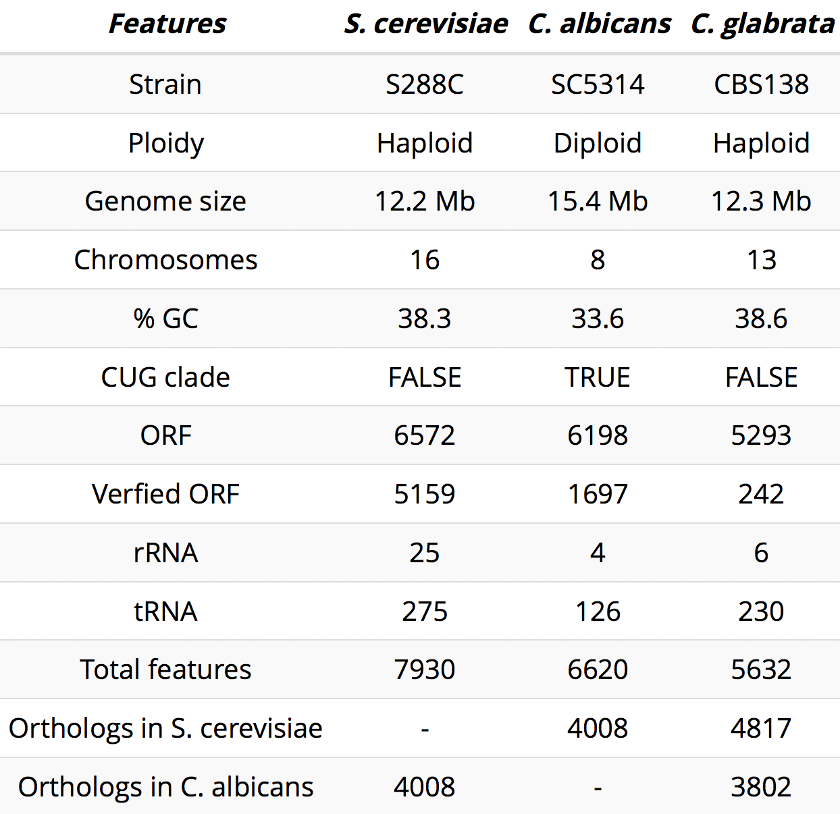

**3.4 Sources of *C. albicans* and *C. glabrata* infections**

Our relationship with *C.* *albicans* and its colonization marks since the age we were born. Carriage of these yeasts is about 50% in infants of age 1 week to 18 months obtained from birth canals. Among this approximately 40% of Candida is isolated from the infant oral mucosa correlating with maternal vaginal Candida carriage rate(Lynch, 1994). Candida carriage also varies with age with average of 18% in healthy individuals and 41% in patients and according to time of day, for instance Candida oral carriage is highest during morning and afternoon (Lynch, 1994). The Candida burden also differs with respect to individual’s age and physiology. FC Odds have classified occurrence of oral Candidiasis broadly based on 1. Natural occurrence, due to metabolic diseases like diabetes, infections. 2. Malignancy, i.e. Leukemia, lymphoma 3. Hormonal or dietary alternations like pregnancy, infancy, old-age variation in dietary supplements, vitamin deficiencies. 4. Mechanical factors, like dentures, antibiotics, hormonal contraceptives (Odds FC. Factors that predispose the host to candidiasis. In: Candida and Candidosis).

As mentioned before, *Candida albicans* burden is higher in Genitourinary tract when compared to other Candida spp. This infection is observed in both male and females however, it is more prevalent in females (Achkar and Fries, 2010; Fisher John, 1982). About 40% of the women suffering with vaginitis are carriage of vulvovaginal candidiasis (VVC), further VVC are also classified as asymptomatic and symptomatic. In asymptomatic VVC, *C. albicans* thrive in healthy vagina with no signs of inflammation while in symptomatic VVC is state which shows signs of rashes, inflammations in absence of any other pathogen than *C. albicans* (Sobel et al., 1998)*.* Usually 75% of the women experience VVC once in their lifespan due to pregnancy, diabetes or immunosuppression but some of the females experience recursive episodes of VVC called as RVVC (Achkar and Fries, 2010; Sobel et al., 1998). Etiology of VVC have shown emergence of

NACS in 10% to 45% of the cases, probably because of their low susceptibility to major mycotic drugs (Makanjuola et al., 2018). In males, asymptomatic colonization of *C.* *albicans* is observed in glans of penis which is sexually acquired. And about 30-35% of all the infections of balanitis are based solely on *C.* *albicans* (Lisboa et al., 2009).

*C. albicans* is also present in gastrointestinal (GI) tract as commensal microbe forming asymptomatic component of our gut microbiota. As these fungal species don’t show any environmental reservoir they grow in close association with the host and interact with other organisms in microbiota. *C. albicans* also show ability to adapt to the host environment enabling effective colonization in humans. The fungal colonization is usually thought to be benign but under inappropriate host conditions they turn to be invasive leading to dreadful infections (Rosenbach et al., 2010). Situations under which the colonization of *C. albicans* increase over the healthy individuals in Crohn’s diseases, i.e. inflammatory bowels are caused when there exist dysregulated interactions between host immune system and intestinal tracts (Kumamoto, 2011; Standaert-Vitse et al., 2009). Candiduria, presence of yeast in urine is another situation in which these commensal organisms turn to be pathogenic. It is observed in nosocomial episodes and diagnosed in two class of individuals 1. Elderly person, under prolong hospitalization and 2. Neonates who are under prolonged antibiotics treatment (Achkar and Fries, 2010). Risk factors associated with Candiduria includes urinary indwelling catheters, prolonged consumption of antibiotics, elderly age, abnormality in genitourinary tract, previous surgery and presence of diabetes mellitus. Candiduria can also be seen in cases of hematogenous, systemic infections due to severe renal candidiasis or patients undergoing from renal autopsy (Bukhary, 2008; Sousa et al., 2014). Since last decade, it is observed that Candiduria is actually mixed infection from NACS which makes it more challenging to design diagnosis methods for identification of causative agents for systematic treatment in species specific manner as utilization of common antifungal drugs leads to development of resistance in one or more species (Voltan, A R, Fusco-Almeida A M, 2014).

*Candida glabrata* is the most common NACS, coexisting with *C. albicans* and *S. cerevisiae*. Under optimal conditions it is restricted to particular location in healthy individuals. The action between host immune system and other microbial communities competes for nutrients and toxin secretion preventing dissemination of this yeast species(Pamer, 2007). However, immunocompromised individuals undergoing organ transplantation, prolonged hospitalization or suffering from dreadful diseases like AIDS are highly susceptible to infections by *C. glabrata* (Kumar et al., 2019; Roetzer et al., 2011). Hence, unlike *C. albicans*, infections caused by *C. glabrata* are less virulent and restricted in only physiologically ill individuals. Effective treatment against *C. glabrata* infections is challenging due to their ability to resist high concentrations of antifungal drugs.

1. **Basics of virulence by *Candida* *spp*.**

Human associated fungi like *Candida, Malassezia* and *Pneumocystis* species are considered as belonging to “commensal virulence school” since they are trained by host’s commensal environment. In commensal environment these species are constantly challenged by other microbial species, host growth factors which upon infection favorable conditions induce virulence (Hube, 2009). However, not all hosts are susceptible to virulence and even closely related fungal species have very different relationships with their hosts. Hence the basis of fungal virulence depends on the extend of hosts susceptibility. The fungal attributes which help them in invading, damaging, counteracting the host immune system and colonizing in non-commensal niches are the true virulence attributes listed below;

**4.1 Adherence**

In order to grow commensally and as pathogen on the host mucosal surfaces, *Candida species* adhere on epithelial cells by expressing the adhesion factors. Surface adhesins and hydrophobicity mediate adhesion regulates attachment to host cells, other microbial species and medical devices like catheter, dentures etc (Esser, 2014). This large surface attachment as multi- or mono- species causes formation of biofilms, and subsequently induced resistance to antifungal drug. In both C. *albicans* and *C. glabrata,* a number of adhesin proteins are present on the cell wall enabling them to establish pathogenesis successfully. Adhesins exposed on the cell surface are usually glycosylphosphatidylinositol (GPI) proteins or GPI anchored proteins governing the host-pathogen interactions like superoxide dismutase, phospholipases, aspartyl proteases (de Groot et al., 2013).

In *C. albicans,* adhesins are classified mainly in three gene families *viz.* ALS, HWP and IFF/HYR (de Groot et al., 2013). Agglutinin like sequence (Als) are the most studied GPI-linked adhesins, consisting of 8 large glycoproteins Als1-Als7 and Als9. ALS3 has been showed in hyphae associated epithelial adhesion with significant contribution in virulence. Als3 is a multi-functional adhesin involved in mixed-species biofilm formation, acts as invasin by promoting endocytosis in host cells. Hwp i.e. hyphal wall proteins, is another class of GPI-linked adhesin required for epithelial adhesion and full virulence during hyphal growth (Esser, 2014). Additionally, about 10 proteins have been classified in IFF/HYR class where IFF means “IPF family F” and HYR means “hyphally upregulated proteins” (de Groot et al., 2013). These proteins have higher level of sequence similarity at their effector N-terminal domain. Studies have shown that IFF11 is important for cell wall organization and enzymatic function while optimal levels of IFF4 induce maximal levels of virulence. Hyr1 is implicated in full resistance against neutrophil killing (Esser, 2014).

About 67 adhesins like genes exists in *C. glabrata,* out of which 44 are located near telomeric region. The specificity of their sub-telomeric locus is postulated to be involved in rearrangements, non-allelic homologus recombination. Many adhesins also contain repeat regions of sequence ‘VSHITT’ for instance in PWP7 and AED1, leading to different local chromosomal rearrangement forming different variants of adhesins (de Groot et al., 2008; Timmermans et al., 2018). All the adhesin like proteins were identified based on their conserved ‘VSHITT’ motif further sub-grouped based on their N-terminal domains. One of them is Epithelial adhesion protein (Epa) with N-terminal ligand binding domain protruding out of cell by highly glycosylated serine/threonine residues enabling the cell for efficient adhesion (Weig et al., 2004). Deletion of *CgEPA1* reduced adhesion by 95% to human macrophage like cells but did not affect colonization, probably due to presence of other Epa proteins (Cormack, 1999). However, *CgEPA1* is the most studied adhesin in *C. glabrata* (Cormack, 1999). *CgEPA6*, was found to be expressed in urinary tract infection model owing to *C. glabrata’s* auxotrophy of nicotinic acid (Domergue, 2005). Biofilm formation of *C. glabrata* is significantly higher than *C. albicans*. Microscopic studies have shown that biofilm formation of *C. glabrata* cells is tightly associated with *C. albicans* hyphae and *EPA8*, *EPA19*, *AWP2*, *AWP7,* and CAGL0F0018g show induced expression upon co-incubation with *C. albicans* hyphae (Tati et al., 2016). Pwps are another group of N-terminal adhesin*,* while other classes were mostly classified based on their ligand binding domain. Pwp7 and Aed1 (adherence to endothelial cells) adhere the fungal cells to endothelial host cells(Desai et al., 2011). Hence, detailed understanding of newly identified adhesins at transcriptional level from clinical isolates will help narrow down the drug targets for efficient treatment.

**4.2 Morphological switch**

As discussed earlier, morphological switching is a key virulence attribute in *C. albicans*. However, mutants arrested in either of the one morphological form i.e. either in yeast or hyphal are less susceptible to infection (Esser, 2014). Hence, which form provokes infection is still a question.

**4.3 Pigmentation**

Pigmentation or melaninization has gained importance as virulence factor in C. albicans and many other pathogenic fungal species (Morris-Jones et al., 2005). Melanins are polymerised phenolic or indolic compounds forming high molecular weight negatively charged, hydrophobic pigments (Nosanchuk et al., 2015). Melanin have special ability to decrease phagocytosis, alter cytokines response and repress the toxicity by antimicrobial peptides, reactive oxygen species, antifungal drug with strengthening of fungal cell wall (Morris-Jones et al., 2005; Nosanchuk et al., 2015).

In *C. glabrata,*  pigmentation occurs when tryptophan is the sole nitrogen source (Mayser et al., 2007). This pigmentation is mediated by Aro8 a tryptophan upregulated aromatic amino transferase as a by-product of Ehrlich pathway (Brunke et al., 2010). Growth of *C. glabrata* on this medium leads to increased resistance against hydrogen peroxide, higher survival rate on contact with human neutrophils and increased damage in monolayer human epithelial model (Brunke et al., 2010). Additionally, treatment of sole pigment compound induces apoptosis in human melanocytes suggesting a vital pathogenesis attribute (Krämer et al., 2005).

**4.4 Signaling cascades**

**4.5 Response to Stress**

Stress response

Heat

Oxidative

Osmotic

Starvation

*Candida spp.* natively live inside the gut microbiota and vaginal tract of immune-competent hosts but during invasive infections host niche alters and hence the nature of these commensal organisms alters to pathogenic. Fungal cell wall plays a vital role as a response to host and host’s immune system.

As mentioned before, in immune-competent individuals Candida spp. live as commensal organism, however,

1. **Host immune response against *C. albicans* and *C. glabrata* infections**

Human body is home for number of microbial species like bacteria, virus, fungi residing on exogenous and endogenous body parts. Maintaining balance of these microbial species is critical for healthy status of our body. Homeostasis of every tissue is under the control of host immune system, restricting the growth of pathogens like *C. albicans* to harmless commensal form. But weaken immune surveillance provides opportunity to these fungal pathogens to readily invade vulnerable patients. For instance, hyphal form of *C. albicans* breaks the mucosal barrier and causes damage to internal tissues, progressing further to host vascular system and finally disseminating in to host system (Richardson and Moyes, 2015). As primary mode to eliminate these pathogens, host body activates cells like macrophages, dendritic cells, neutrophils which form innate immune system. However, if the pathogen breaches this primary defense system, innate immune system signal’s activation of specialized immune cells i.e. T-cells, B-cells in order to get rid of this dreadful pathogen.

* 1. **Macrophages**

Macrophages are phagocytic cells, having ability to engulf and digest cellular debris, any foreign bodies, pathogens, cancer cells etc. Macrophages can circulate to the site of infection or can be stable tissue-resident macrophages (Xu and Shinohara, 2017). Depending on their residence they are further classified as (Table 3). Macrophages also recruit other immune cells for efficient killing of pathogens. Studies have highlighted Candidacidal activities of different macrophages eliminate Candida burden (Mansour and Levitz, 2002). They recognize extracellular (ß-glucan, mannan) and intracellular (DNA, RNA) Pathogen Associated Molecular Patterns (PAMPs) present on Candida species through specialized Pattern Recognition Receptors (PRRs) after initial infection.

**Table 3: Classification of macrophages according to their origin.**

**Adapted from** (Xu and Shinohara, 2017)

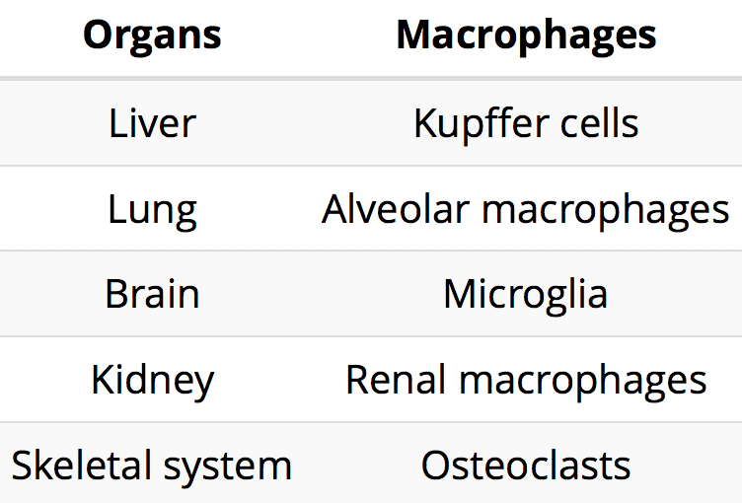

*Candida albicans* cells are recognized by Toll-like receptors (TLRs: TLR2, TLR4), C-type lectin receptors (CLRs: dectin1, dectin2), Mannose Receptor and Complement Receptor CR3 based on the cell wall composition. ß-glucan present in *C. albicans* cell wall activates macrophages by inducing production of proinflammatory cytokines and chemokines in order to gain resistance against pathogenic fungi (Kiyoura and Tamai, 2015). Additionally, 1-3ß-glucan also trains macrophages and monocytes in developing the immunological memory, preparing immune cells for future Candida attacks(Quintin et al., 2012). Post phagocytosis, the ingested *C. albicans* cells provokes macrophages to produce antimicrobial effectors like Reactive Oxygen Species (ROS), Reactive Nitrogen Species (RNS) and antimicrobial peptides. Although majority of the pathogens are cleared by macrophages, some still manage to survive. Phagocytosed cells are used as immune modulators in antigen presentation to recruit more immune cells. But the resistant cells cope with macrophage stress by expressing Super Oxide Dismutase (SODs) to detoxify the ROS and secreting mediator which inhibits activity of nitrogen oxide synthase (Frohner et al., 2009). Phagocytosed *C. albicans* cells also undergo transition from yeast to hyphal form leading to lysis of macrophages membrane. Cell wall composition of hyphae is different than yeast, helping the fungi to escape the immune surveillance leading to successful dissemination of *C. albicans* in blood*.* Recent studies have shown that hyphal form *C. albicans* is capable of inducing pyroptotic cell death in macrophages another way to escape the phagocytosis (Uwamahoro et al., 2014).

*C. glabrata*are also recognized by Dectin-1 and Dectin-2 receptors of CLRs present on macrophages. Unlike *C. albicans* they do not undergo morphological switching upon phagocytosis rather they survive and proliferate inside the macrophages without significantly affecting them (Kaur et al., 2007; Rai et al., 2012; Seider et al., 2011). Moreover, phagocytosed *C. glabrata* cells do not activate macrophage associated signaling pathways and subsequently the proinflammatory cytokines are not produced (Kasper et al., 2014; Seider et al., 2011). But they induce GM-CSF functioning as cytokines in macrophages and other cell-types like T-cells, mast cells. Studies have shown that *C. glabrata* impedes macrophage maturation by inhibiting acidification of phagolysosomes to evade macrophage killing and successfully replicate(Kasper et al., 2014; Seider et al., 2011). Autophagy, chromatin remodeling and surface aspartyl proteases mediated activation of the spleen tyrosine kinase, syk pathway upon phagocytosis could be different strategies adopted by this fungus to survive and replicate (Rai et al., 2012; Rasheed et al., 2018; Roetzer et al., 2010). However, exact mechanism how they proliferate in macrophages still remains unclear.

* 1. **Neutrophils**

Neutrophils also form the first line of defense and have ability to phagocytose opsonized and unopsonized fungal pathogens killing them through oxidative or non-oxidative pathways. Neutrophils express soluble, membrane bound PRRs like CLRs, TLRs, integrins and Fc-gamma receptors (Gudlaugsson et al., 2003). After the PRRs and PAMPs interactions cytotoxic response is elicited and the ITAM-like motif in the tail of dectin-1 gets phosphorylated further activating syk pathway. Later, downstream pathways like translocation of NFkB to nucleus mediated by CARD9 (caspase-associated recruitment domain) associated Malt1 and Bcl10 for cytokine production are also activated(Gringhuis et al., 2009). This in turn triggers ROS production by NADPH oxidase system, granula-derived proteases release, neutrophils extracellular traps (NETs) and antimicrobial peptides. Additionally, cytotoxic mechanisms also involve release of both pro- and anti-inflammatory cytokines to signal differentiation of other immune cells (like T-helper) at the site of infection for effective immune response(Gazendam et al., 2016).

Yeast to pseudohyphae transition of *Candida albicans* is successfully inhibited by neutrophils. Ingestion of *Candida* formulates NADPH oxidase complex in phagosomal membrane, performing three main function: 1. yeast killing, 2. inhibition of *Candida* filamentation 3. recruiting phagocytes at the *Candida* infected tissues. Cascade of reactions takes place post NADPH oxidase complex activation like generation of superoxide anion, formation of hydrogen peroxides (H2O2), conversion of H2O2 to hypochlorous acid by myeloperoxidases, these ROS further induce K-flux-dependent neutrophil proteases production in phagosome for efficient *Candida* killing(Lionakis, 2014). Extracellularly NETs are formed, in which neutrophil DNAs are covered with granular proteins, elastase, myeloperoxidases, calproteins restricting the pseudohyphal growth of *C. albicans*(Lionakis, 2014; Urban et al., 2006). Together, these facts highlight that neutrophils either by oxidative or non-oxidative means play vital role in killing *Candida*, hence patients suffering from neutropenia are at high risk of *Candida* infections. Intriguingly, neutrophils number and timing are important for efficient killing. Studies have shown that before contacting with *Candida* cells, trafficking the site of infection within 24hr is critical for neutrophils, as delayed recruitment would render neutrophils inefficient to invade the pathogens(Lionakis et al., 2011).

*Candida glabrata* are readily trapped in neutrophilic NETs upon engulfment and further get killed. Chemoattractant like MIP-1œ and MIP-1ß are secreted by *C. glabrata* activated neutrophils to induce migration of other monocytes at the site of infection(Duggan et al., 2015). Studies have also shown that phagocytosed *C. glabrata* cells are also dumped to elicit immune response (Essig et al., 2015). In response to neutrophil attack this fungal pathogen produces tryptophan-based pigment to protect itself (Johnson et al., 2017), however, details of *C. glabrata*-neutrophil relations are not yet clear.

* 1. **Antimicrobial peptides**

Antimicrobial peptides (AMP) are small sized (10 - 50 amino acids), positively charged, cationic, amphipathic structures neutralizing variety of viruses, bacteria, protozoa and fungi. They show antimicrobial activity specifically by 1) Inhibiting DNA, RNA and protein synthesis. 2) Binding to DNA and RNA 3) Membrane permeabilization. 4) Inhibition of cell wall synthesis and enzyme activity. 5) Protein folding repressor. 5) Inducing apoptosis (Bondaryk et al., 2017). Natural AMPs act as first line of defense against pathogens showing little toxicity against human cells and are stable under different conditions. They also signal neutrophils and monocytes to migrate towards the site of infection. Histatins, defensins and cathelicidin LL-37 are majorly found AMPs in humans (Swidergall and Ernst, 2014). Depending on their mechanism of action, antifungal AMPs are classified as 1) Peptides which traverse the cell membrane and form pores in it or act on specific targets like ß-glucan or chitin synthesis. 2) non traversing peptides interacts with cell membrane and causes cell lysis(Bondaryk et al., 2017; Swidergall and Ernst, 2014).

Histatin-5, AMP produced in salivary glands regulates growth of *Candida* cells, since HIV patients with low levels of Histatin-5 show induced oral Candidiasis. Histatin-5 follow multistep process for its fungicidal effect; 1) Peptide binds to ATPase domain of the cell envelope proteins Ssa1 and Ssa2 2) Peptide accumulates intracellularly by utilizing fungal polyamine influx transporter Dur3 and Dur31, forming reactive oxygen species (ROS), efflux ions and ATP subsequently causing cell death (Swidergall and Ernst, 2014). However, different strains of *C. glabrata* showed insensitivity towards higher concentrations of Histatin (Helmerhorst et al., 2005). α-defensins present in human neutrophils act on energy metabolism process by depletion of intracellular ATP levels and increases extracellular ATP concentrations to kill *C. albicans.* ß-defensins causes membrane permeabilization leading to cell death. LL-37 initially associates with the cell-wall or cytoplasmic membrane hence affecting their (*C. albicans*) adherence to oral cavity and urinary bladder epithelial cells. Cell wall remodeling mediated by Xog1 (a *C. albicans* cell wall exoglucanase) - LL-37 interaction lowers adhesion (Swidergall and Ernst, 2014). The inhibitory effects exhibited by these natural AMPs on fungal growth, highlight their potential as important antifungal therapeutic agent.

* 1. **Dendritic cells**

Dendritic cells (DCs) acts as link between innate and adaptive immune system, initiating the adaptive immune response against pathogens. DCs are specialized immune cells capable of engulfing antigen and presenting antigen peptides on the cell’s major histocompatibility complex (MHC) class I and class II which are recognized by CD4+ and CD8+ T-cells respectively(Ramirez-Ortiz and Means, 2012). DCs are constantly patrolling for pathogenic antigens through PRR to activate pathogen specific T-cells. Specificity of DCs help them discriminate between yeast and hyphal forms of *C. albicans* primarily based on the cell wall composition. Binding and internalization of *C. albicans* by human DCs is mediated by C-type lectins, DC-SIGN and macrophage mannose receptor(Ramirez-Ortiz and Means, 2012). Mannan polysaccharides present in cell wall exterior are primarily involved in interaction of fungal species with host immune cells. Mannans have α-1,6-bonds and side chains of varying lengths which makes different structures for each pathogenic fungal species leading to formation species-specific antigens(Paulovičová et al., 2019). Although *C. glabrata* mannan is similar to *S. cerevisiae*, *C. glabrata* shows absence of long side chain moreover mannan composition also differs within *C. glabrata* strains(Takahashi et al., 2012).

Post fungal recognition cytokines are secreted by DCs and series of co-stimulatory molecules are presented on the DC surface which help differentiation of CD4+ T cells into subset of T-helper cells, Th1, Th2, Th17 and T-reg (T regulatory) (Roy and Klein, 2012). Tolerogenic DCs induce Th1 and T-reg cells while inflammatory DCs trigger antifungal Th2 and Th17 T-cells. This is in congruence with studies showing pathogenic filamentous form of *C. albicans* provokes development of anti-Candida Th17 cells, suggesting clear discrimination between pathogenic and commensal form (Gow et al., 2012). This critical role of DCs in clearing fungal infections make them potent target to design novel vaccines and yeast immunization (Roy and Klein, 2012).

* 1. **T-cells**

As mentioned above, DCs activate naïve T-cells via MHC I and II by formation of immunological synapse. T-cells are classified as helper T-cells (CD4+) and Cytotoxic T-cells (CD8+) both of them play vital role in eliminating fungal infections. CD4+ cells are further classified as Th1, Th2, Th9, Th17, Th22, T-reg and follicular T-cells of which Th1 and Th17 have been reported to be involved in antifungal immune response (Kumaresan et al., 2017). To fight against pathogenic fungi Th1 cells secrete cytokines IFN- γ and TNF-α, provoking innate immune system cells like macrophages, DCs, monocytes, neutrophils and B-cells (Kumaresan et al., 2017). Th17 T-helper cells secrete IL-17 to restrict fungal infection by mobilizing neutrophils as well as activates epithelial cells to secrete defensin in order to protect mucosal sites (Hernández-Santos and Gaffen, 2012). Studies have shown increased susceptibility to *C. albicans* in IL-17 deficient cases (Huppler et al., 2012).

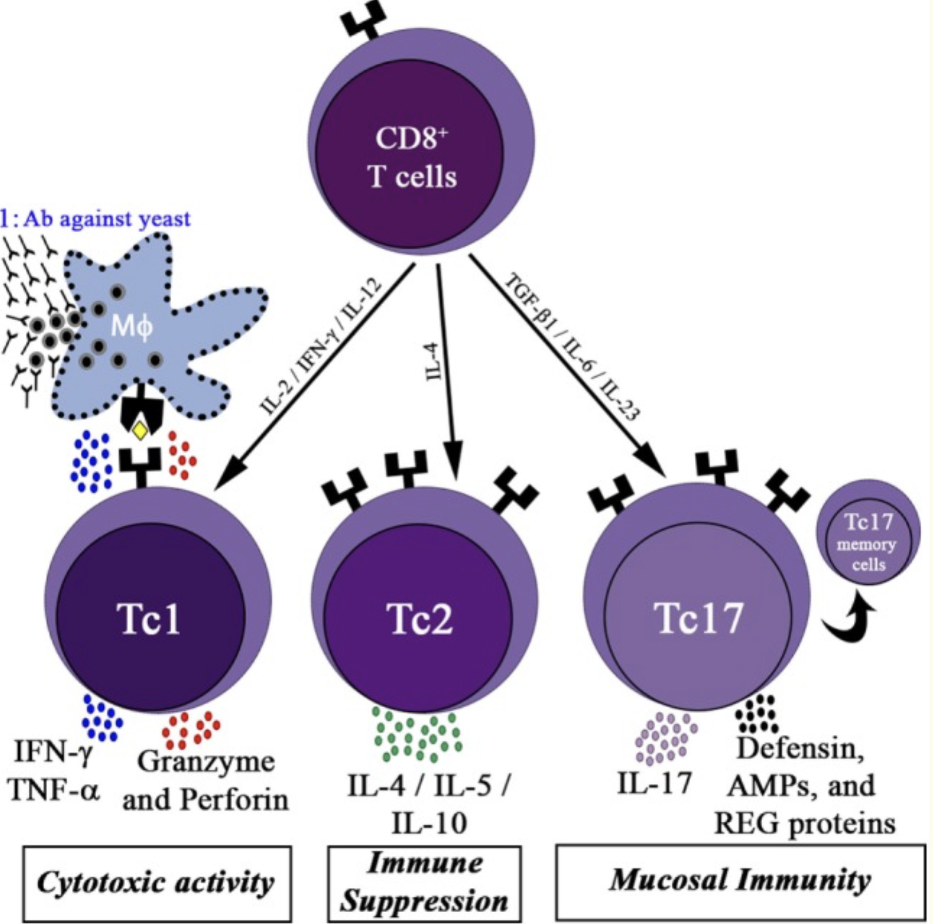

Figure 4: Classification of cytotoxic T-cells. (Kumaresan et al., 2017)

Similar to CD4+ cells, CD8+ T-cells are classified as Tc1, Tc2 and Tc17 (Figure 4). Depending upon the cytokines present in the environment Tc1 or Tc17 cells get differentiated upon detection fungal peptides on antigen presenting cells. Tc1 cells can either directly kill unresponsive fungi-engulfed macrophages by the secretion of perforins, granulysin and granzyme K or indirectly by activating neutrophils and macrophages by secreting cytokines like IFN- γ, GM-CSF and TNF-α (Lin et al., 2005). Tc17 cells are functionally similar to Th17 of CD4+ cells. Based on the receptors present on the surface of these cells Tc1 and Tc17 cells subtypes are divided as effector T-cells and effector T memory cells. Studies have shown that in the absence of CD4+ cells, CD8+ cells play major role in clearing fungal infection forming a vital target for T-cell therapy (Kumaresan et al., 2017).

* 1. **B-cells**

B-cells are primarily involved in adaptive humoral immune response producing antigen-specific immunoglobulin (Ig) against pathogens.

1. **Antifungal Drugs**

Increase in immuno-compromised individuals, emergence and re-emergence of the pathogens have increased the incidences of fungal dissemination in last few decades. Owing to this increase the clinical use of antifungal drugs has exponentially increased to control fungal infections. However, use of broad-spectrum antifungal drugs have evolved growth of drug resistant isolates of pathogenic fungi. Also, each species varies in terms of its virulence traits, ability to form biofilms, adherence to host, production of enzymes causing difficultly in their treatment (Bersani et al., 2019; Davies, 2003). To combat these problems lot of resources are being invested and research is carried out to develop novel, safer and effective species-specific antifungal drugs. Since fungal cell wall alters in response to human immune system, components of cell wall are primarily used as drug targets. Listed below are the classes of fungal drugs commonly used during invasive candida infections;

* 1. **Polyenes**

Polyenes were the only class of antifungal drug available classically with first clinical use in 1950s.

Amphotericin B is a polyene in deoxycholate formulation or lipid formulation, it is been widely used in invasive infection. Amphotericin was isolated from soil bacteria *Streptomyces nodosus* in 1955 and in 1958 it was approved for medical use (Richard Calderone, 2012). ­It is been broadly used against pathogenic yeast like *Candida spp.*, *Cryprococcus spp.*; filamentous fungi like *Aspergillus spp.* and many dimorphic fungi for instance *Paracoccidioides spp.*, *Blastomyces dermatitidis*, *Histoplasma capsulatum* (Richard Calderone, 2012).

Amphotericin-B is amphipathic, containing both hydrophilic and hydrophobic moieties. It specifically acts on ergosterol molecules in the fungal cellular membrane forming pores in the membrane. Pores allow leakage of intracellular material causing destruction of proton gradient and ultimately leading to fungal cell death (Ghannoum and Rice, 1999; Vanden Bossche et al., 1994). Due to poor solubility of amphotericin B is solely available in intravenous formulation. This drug has relatively longer half-life and upon infusion the drug level remains elevated for 6-8h (Richard Calderone, 2012). Since the detectable concentration of lipid formulation were very low in brain liposomal formulation was used having 10 times more detectable concentration than lipid formulation in order to treat against meningitis (Richard Calderone, 2012).

Although it is been primarily recommended antifungal drug, amphotericin B pose side effects as renal damage, hepatotoxicity and infusion related reactions. Among the three formulation deoxycholate form is highly toxic while lipid form is less toxic but expensive (Richard Calderone, 2012). Usually, Lipid based formulation is first line treatment to candidemia or neutropenic patients with suspected candidiasis. While deoxycholate forms second line of treatment for non-neutropenic candidiasis patients. And liposomal formulations are prevalently recommended in patients suffering from candidiasis of central nervous system, cardiovascular system or eyes (Richard Calderone, 2012).

Resistance to amphotericin B is rare in *Candida spp.,* but resistivity is usually associated with low levels of ergosterol in cellular membranes. In *C. glabrata,* clinical isolates with loss function mutation in ergosterol biosynthesis genes have reported to be resistant (Hull et al., 2012). Intriguingly, *C. glabrata* have unique ability to uptake sterols from host in order to overcome ergosterol deficiency due to mutation (Nagi et al., 2013).

* 1. **Allylamines**

An unwanted product naftifine (an allylamine) of central nervous system drug discovery project accidentally gained importance for its antifungal activity. Allylamines (terbinafine and naftifine) show inhibitory effect on squalene epoxidase (Erg1) (Figure 5) involved in catalysis of squalene to 2,3-oxidosqualene causing accumulation of toxic squalene in fungal cells. In case of *C. albicans*, lower concentration of drug show fungistatic effect while higher concentration has fungicidal effect in ectopic infections (Hartman and Sanglard, 1997). Terbinafine is highly effective against dermatophytes in systemic and topical infections like toenail infections (Balfour and Faulds, 1992). However, in non-dermatophytic infections like invasive aspergillosis, disseminated fusariosis, scedosporiosis or oral candidosis efficacy of terbinafine is underappreciated. Studies suspect that if administered in combination with other antifungal drugs terbinafine might be effective against resistant yeast/mold or other non-dermatophytic infections (Krishnan-Natesan, 2009).

* 1. **Morpholines**

Morpholines are compounds with large ring N-substituents having fungicidal activity in fungi infected plants and animals (Mercer, 1991). Unique characteristic of morpholines, amorolfine acting specifically on human pathogenic fungus is that it inhibits activity of two different enzymes of the same ergosterol biosynthesis pathway (Figure 5). Usually two or more drugs are administered in combination for this type of enhanced antifungal activity, on contrary it is difficult for any fungal species to gain resistance by mutating two enzymes (Hartman and Sanglard, 1997; Jachak et al., 2015). Amorolfine inhibits enzymes *viz.* sterol Δ14 reductase (Erg24) and sterol Δ7-Δ8 isomerase (Erg2) catalyzing zymosterol and episterol synthesis respectively. Disruption of gene encoding Δ14 reductase affects cellular viability in aerobic conditions while enzymatic activity inhibition leads to accumulation of ignosterol (Hartman and Sanglard, 1997). Antifungal spectrum of amorolfine shows effectiveness against topical nail infections caused by *Alternaria spp*., *Hendersonula spp., Scopulariopsis spp*. but infective invasive infections due to its rapid metabolism inside host (Hartman and Sanglard, 1997; Jachak et al., 2015). To overcome this restriction, silicon incorporated stable and potent amorolfine analogues are being developed against pathogenic fungi. However, impact of morpholines drug on *Candida spp.* is been poorly reported (Jachak et al., 2015; Luna-Tapia et al., 2015).

Figure 5: Drug targets in ergosterol biosynthesis pathway. (Onyewu et al., 2003)

* 1. **Azoles**

Azoles are chemically classified as imidazole (clotrimazole, ketoconazole, miconazole) with 2 nitrogen atoms and triazoles (fluconazole, itraconazole, posaconazoles and voriconazole) containing 3 nitrogen atoms, miconazole was the first drug to be licensed for its antifungal activity. However, imidazole family drugs like miconazole and ketoconazole induce severe toxicity while triazoles are relatively safe and well tolerated in systemic infections treatment. Azoles primarily act by blocking lanosterol demethylase enzyme, a cytochrome P-450 enzyme, encoded by *ERG11* (Figure 5) in ergosterol biosynthesis pathway. Inhibition of Erg11 leads to accumulatio of toxic sterol intermediates and depletion of ergosterol resulting in altered membrane permeability (Heimark et al., 2002; Richard Calderone, 2012; Wood et al., 1994). This imbalance in cellular sterol levels leads to cessation in fungal growth and, hence controlling fungal pathogenesis. Higher level of azoles binds directly to lipids in cell membrane rendering them unavailable for the cells. However, azoles only suppress fungal cell growth and not completely abolish like Amphotericin B or Echinocandins (Richard Calderone, 2012).

**Table 4: Spectrum of azole drugs. Adapted from** (Richard Calderone, 2012)

Fluconazole is a small molecule and highly soluble hence can be easily administered orally and known to be effective in most body tissues. Bioavailability of fluconazole is about 90% and is at peak concentrations after 2-3hr of administration moreover therapeutic levels of fluconazole are maintained for more than 72hr (Richard Calderone, 2012). However, native form of voriconazole, itraconazole and parconazole have very low aqueous solubility refraining them from oral intake. Various formulations have been developed for their easy administration. Unlike fluconazole; itraconazole and posaconazole bioavailability varies with pH of the gastric environment. While voriconazole’s bioavailability is higher in fasted state together these azoles lead to gastrointestinal complaints. Although azoles are less toxic antifungal drugs, studies show that voriconazole exhibits side-effects like defects in vision (photopsia), skin rashes and dose dependent hepatotoxicity (Richard Calderone, 2012). Recently, a more soluble form of triazole isavuconazonium sulfate, a prodrug of isavuconazole was approved in invasive aspergillosis and invasive mucormycosis(Jenks et al., 2018; Sanglard and Coste, 2016) . It has proven to have good efficacy in mouse models of candidiasis. But evaluation and comparison with other azole compounds showed similar activity range of isavuconazole on different Candida clinical isolates (Sanglard and Coste, 2016).

Resistance against fluconazole has been reported in *C. albicans* clinical isolates and while many non-albicans candida spp. are also known to show high degree of resistance against azoles. In *C. albicans* at least four fluconazole resistance mechanisms have been reported: 1) Mutation in ERG11 gene leads to amino acid substitution and subsequently decreased susceptibility (Flowers et al., 2015). 2) Increased ERG11 expression mediated by Upc2 transcriptional regulator (Dunkel et al., 2008). 3) Overexpression of drug efflux pumps Mdr1 and Cdr1/Cdr2 (Coste et al., 2007). 4) Inactivation of ERG3, which converts non-toxic sterol to toxic one in the final steps of ergosterol biosynthesis pathway (Morio et al., 2012). Intriguingly, in clinical isolates of *C. glabrata* induced expression of ERG11 was found due to duplication of entire chromosome containing ERG11(Marichal et al., 1997). Many of the *C. glabrata* resistant isolates have strong association with mutations in Pdr1, a pleiotropic drug response regulator causing distinct expression patterns in target drug transporter genes (Vermitsky and Edlind, 2004). *C. glabrata* also exhibits ability to grow with altered cell membrane sterols levels and uptake of exogenous sterol under normal conditions and during blockage of ergosterol pathway leading to enhanced azole resistance (Bard et al., 2005; Whaley et al., 2016).

* 1. **Flucytosine**

Flucytosine, 5-fluorocytosine or 5-FC was synthesized first in 1957 as an antitumor agent but proved to be ineffective against tumors. Later in 1961, it was proved to be potent antifungal drug against Candidiasis, Cryptococcosis and Chromoblastomycosis inhibiting fungal RNA and DNA synthesis (Vermes et al., 2000). 5-FC is a pro-drug initiating antimycotic activity upon conversion of 5-FC to 5-fluorouracil (5-FU). 5-FC is taken-up by cytosine permease, an enzyme required for transport of adenine, cytosine and hypoxanthine. The intracellular 5-FC is then deaminated by cytosine deaminase to 5-FU. Lack of cytosine deaminase in mammalian cells make 5-FC a potent pro-drug. 5-FU exerts antifungal activity at least in two ways 1) 5-FU is first converted to 5-flurouridine monophosphate (FUMP), then to fluorouridine diphosphate (FUDP) and later to fluorouridine triphosphate (FUTP). FUTP is taken-up as an alternate form of uridylic acid in fungal RNA, altering the amino-acylation of tRNAs, amino acid pool and further inhibiting protein synthesis. 2) 5-FU is converted to 5-fluorodeoxyuridine monophosphate (FdUMP) by enzyme uridine monophosphate pyro-phosphorylase. FdUMP inhibits thymidylate synthetase activity, which is important source of thymidine in DNA synthesis (Kathiravan et al., 2012; Vermes et al., 2000).

Emergence of fungal resistance against 5-FC is widely reported due to its dosage as a single agent. Two resistance mechanism have been reported: 1) mutations in 5-FC dependent enzymes like uridine monophosphate pyro-phosphorylase, cytosine permease and/or cytosine deaminase. 2) Increased synthesis of pyrimidines to compete with fluorinated antimetabolites of 5-FC also induces resistivity (Vermes et al., 2000). Mutations in cytosine deaminase *FCA1* (*C. albicans*) and *FCY1* (*C. glabrata*) leads to deficient levels of the enzyme resulting in reduced downstream processing and toxicity of the drug. Owing to frequent development of 5-FC resistance, dosage of 5-FC is been combined with other drugs like amphotericin-B or azoles in case of systemic infections (Sanglard, 2016). 5-FC is administered orally as capsule with excellent bioavailability. It has short half-life (4-5h) and hence needs to be frequently administered (Richard Calderone, 2012; Vermes et al., 2000). It is not metabolized in host body and remains accumulated in different tissues and fluids like cerebrospinal fluid, ocular fluids. However, patients with renal insufficiency should be treated cautiously as they can face toxicity. 5-FC consumption also causes hepatotoxicity, bone marrow suppression and nausea, diarrhea, vomiting, rash as some of the side-effects (Richard Calderone, 2012; Vermes et al., 2000).

* 1. **Echinocandins**

Lead compound for first drug of echinocandins, anidulafungin was identified in 1974, later in 1989 and 1990 precursors for caspofungin and micafungin were identified respectively (Denning, 2003). Echinocandins, a lipopeptide molecule target specifically to cell wall enzyme β-1,3-D-glucan synthase of many pathogenic fungi. Chemically, amphiphilic cyclic hexapeptides with an N-linked fatty acyl side chain intercalates with phospholipid bilayer of the cell membrane. It is noteworthy that mammalian cells lack cell wall making this class a potentially important antifungal drug (Denning, 2003). In case of filamentous fungi, they suppress growth by acting on the hyphal tips while complete growth is abolished for *Candida spp.* Echinocandins have low activity against *Cryptococcus spp.*, Zygomycetes group, *Scedosporium spp.* (Denning, 2003; Richard Calderone, 2012)*.* Considering the safety and effectiveness of echinocandins, they are first-line option for antifungal therapy in disseminated candidiasis and candidemia. Several trials have shown their efficacy comparable to fluconazole and amphotericin-B in esophageal and oropharyngeal candidiasis (Richard Calderone, 2012). But easy administration and low-cost makes fluconazole the first choice of physicians in candidiasis therapies.

Echinocandins are mainly consumed intravenously with average half-lives of 10-26h. However, they have poor activity against infections occurring in cerebrospinal fluid, eyes or urine. As mentioned before echinocandins are very safe antifungal drugs with minimal side effects as: stomach upset, headaches, elevated levels of aminotransferase enzymes and histamine like symptoms (Denning, 2003; Richard Calderone, 2012). *Candida spp.* are predominantly susceptible to echinocandin drugs with some exceptions like *C. glabrata,* resistant to higher levels of drug(Perlin, 2015). Emergence of drug resistant strains is suspected due to repeated and prolonged exposure­­ of azoles and echinocandins in prophylaxis. Mutations in FKS genes encoding catalytic subunits of glucan synthase leads to induced resistance (Denning, 2003; Perlin, 2015). Hotspot regions of FKS gene forms extracellular membrane surface and are known to be potential sites of interaction for the drug, mutation in these spots inhibits drug’s entry into cell (Perlin, 2015).

Number of drugs acting with specific mechanism have been discovered to overcome the fungal burden in immunogenically weak individuals. However, decades of research and clinical trials are still unable to cope with rapid emergence of drug resistant pathogenic fungal strains. Need of more effective compounds acting against range of highly pathogenic non-albicans candida species and filamentous fungi provokes development of more promising antifungal drugs. Understanding the molecular basics of fungal response at gene and genome levels in varied environmental conditions encountered by pathogenic fungi will be a driving force to carry forward screening and development of more potent compounds in target-based treatments.

Response of humans to fungal infection

Pathogenic response to human immune system

Gene expression regulation

Candida specific

Candida albicans

### Candida glabrata

Gene expression regulation

Analyzing

Stress response

Heat

oxidative

Osmotic

Carbon

Chapter 1: Integration of genomics data to infer stability in C glabrata

Chapter 2: Multiple stress responses by C glabrata

Chapter 3: Heat stress response in pathogenic fungi